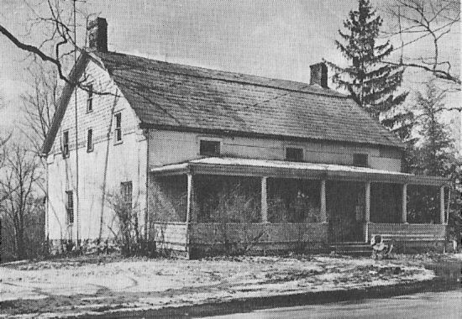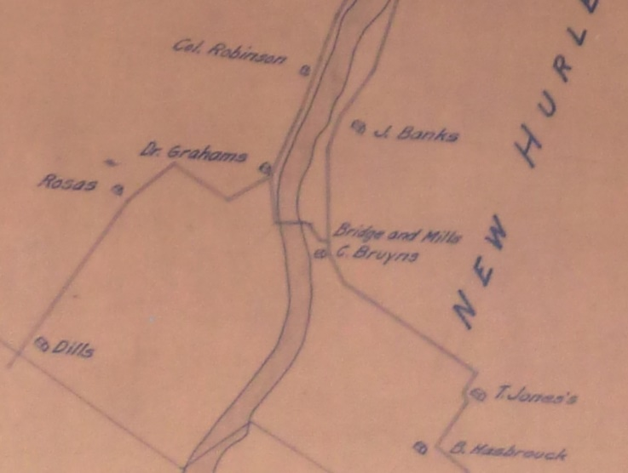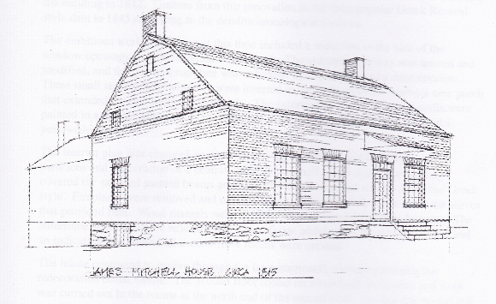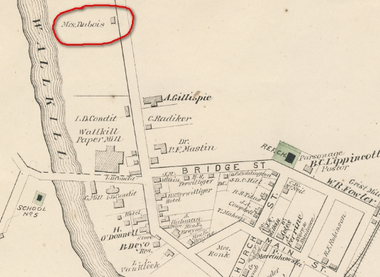

Website http://WallkillHistory.com

Historical Society of Shawangunk & Gardiner

DuBois House 1955

* One-Room Schoolhouse Display
* DuBois pictures and memorability
* Tour the 1869 Andries DuBois House
* All Invited - Free

1798 Map of Wallkill Showing a Bridge

Sketch of 1815 Andries DuBois House after Fire

1875 Map of Wallkill

**An Evening of conversation and pot-luck food at the Historic Andries DuBois House:**

* • Wine, Cheese, Appetizers, Deserts and finger foods
* • Bring your favorite dish to share
* • **Utensils, plates, cups etc. provided**

Location: Andries DuBois House

75 Wallkill Avenue, Wallkill NY 12589

Wednesday December 7, 2016 at 6 PM

An Evening at the 1769 DuBois House

Historical Society of Shawangunk & Gardiner meeting